NHS Data Analysis – Technical Report

Background
The NHS must understand the utilisation trends of components in its network so they can budget correctly when considering infrastructure and resource changes to match an increasing population. To better understand the issues, they have provided historical data and asked 2 questions, which I have broken down:
- Has there been adequate staff and capacity in the networks?
  - Is the mix of staff correct?
  - Is capacity utilised consistently?
  - How do DNA’s affect capacity?
  - Will increasing patient numbers affect capacity?

- What was the actual utilisation of resources?
  - Are some resources overstretched while others are barely used?
  - Can we make better use of all resources to ease pressure points?
  - Can we do anything to reduce the number of DNA’s?

Analytical Approach
The data provided by the NHS was as follows:
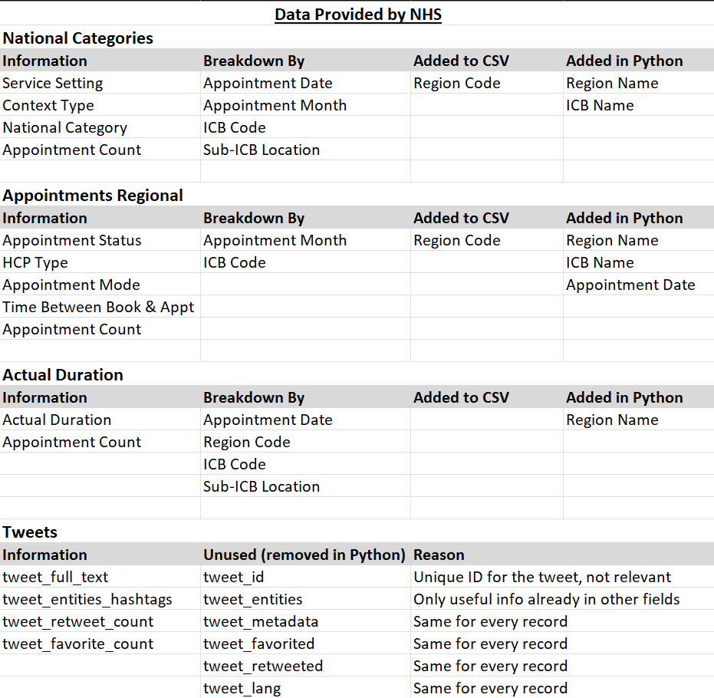
Region codes and names were added to all csv’s to allow for grouping by region and to add detail for whet the region codes represent. ICB names were added to National Categories and Appointments Regional to allow for ICB breakdowns.
Appointment Date (all set to 1st of month) was added to Appointments Regional for continuity.
Appointment Date is not stored as a date in Actual Duration, so this was updated to a datetime in Python.
No other data cleaning was required. There are no NULL entries in the data. The data in each file has aggregated appointment counts, different date ranges, different levels of granularity and no unique identifiers so cannot be merged.
To determine if the number of appointments across data sets matches up, I created a pivoted data set in Excel from National Categories to get the appointments by ICB for the common date range (01/12/2021 - 30/06/2022), then did the same for Actual Duration and Appointments Regional for appointments in the same date range. I added these two sets of results to a new csv file (appts_Dec21_Jun22.csv, provided separately), and added calculations to get the DNA and Unknown breakdowns for comparison.

I used this data to create an additional CSV file including patient numbers using additional data from here: NHS Patient Data (icb_location_patients_appointments_Dec21_to_Jun22.csv, provided separately).
Finally, I created 2 additional CSV files to explore DNA percentages by appointment mode. For this I loaded the data into SQL and created queries to extract the data and saved the results as CSV files. SQL Queries DNA-Unknown-By-Month-Aug21-Onwards.sql and DNA-Unknown-Aug21-Onwards.sql are also provided. Please note, I split appointment month into Month and year after importing for ease of use.
Any additional merging, filtering and grouping of data was done in python as required for the task at hand and is documented in the notebook.

Table screenshots here??

Visualisations and Insights
350 words

Describe the rationale for your visualisation selection to business stakeholders and ensure that the interpretations of the visualisation outputs are detailed, insightful, and relevant to the business objectives.

Patterns and Predictions
200 words

Clearly articulate any patterns, trends, or insights you discovered. Ensure they relate to the business scenario. Include recommendations on any areas for further exploration.

Save as: Blease_Samantha_DA201_Assignment_Report.pdf

